PRESS RELEASE
April 02, 2025

Kubota and Liebherr announce partnership for OEM supply of Wheeled Excavators

Kubota Corporation (Head Office: Naniwa-ku, Osaka, Japan; President and Representative Director: Yuichi Kitao; hereinafter “Kubota”) has agreed to receive OEM supply of 9-ton and 11-ton class wheeled hydraulic excavators from Liebherr-International AG (Headquarters: Switzerland; President of the administrative board: Jan Liebherr, hereinafter referred to as “Liebherr”) for the European market. Production of these products is scheduled to commence at Liebherr in 2026. We are pleased to announce that two new wheeled excavators will celebrate their premiere for the public at Bauma 2025, the world’s most important trade fair for the construction and mining industry, which will take place in Germany starting April 7th.
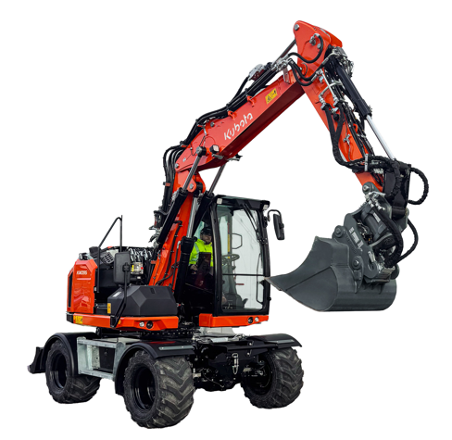

Picture: KW095 (9t Model)

1. Background and objectives
- With the growing global demand for housing driven by population growth, increased infrastructure investment, and urban development, the construction industry is experiencing a significant rise in projects. This surge, coupled with labor shortages, has led to a heightened demand for efficient and labor-saving construction machinery.
- Kubota, a leader in small construction machinery for urban projects, holds the top market share* both domestically and globally for crawler excavators under 6 tons. Our machines are renowned for their exceptional durability, and particularly their operational efficiency in confined spaces. Meanwhile, Liebherr, a family-run technology company and one of the largest construction machinery manufacturers in the world, is among the leaders in the wheeled excavator market and is known for its high-quality medium to large construction machinery.
- On construction sites across Europe, a variety of machinery sizes and types are used in combination. We have received an increasing demand from our customers in Europe for wheeled excavators.
- Since the early stages of this project, Kubota and Liebherr have been working together, conducting market research and defining product concepts. As part of this collaboration, Kubota will receive OEM supply of newly developed 9-ton and 11-ton class wheeled excavators from Liebherr for the European market, starting in 2026.
- Notably, these excavators will be the first Liebherr products to feature Kubota engines.
- With the expansion of our product lineup, we aim to further enhance our position as a comprehensive manufacturer of compact construction machinery in the European market.
2.Product Overview
Model Name | KW095 | KW115
Machine Weight | 9,700 – 11,500 kg | 10,800 kg – 12,800 kg
Engine | Kubota V3800 Stage V (55kW or 80kW)
Intend of Use | Civil engineering in urban area, Road construction

3. About Kubota and Liebherr
Company name | Kubota Corporation | Liebherr-International AG
Representative | Yuichi Kitao,  President and Representative Director | Jan Liebherr,  President of the administrative board of Liebherr-International AG
Head Office | Naniwa-ku, Osaka,  Japan | Bulle, Switzerland
Establishment | 1890 | 1949
Consolidated sales | 3,020.7 billion yen(Group)  647.6 billion yen  (Construction Machinery business)  (Fiscal year ended December 31,2024） | 14.042 billion euros (Group)  9.557 billion euros  (Construction Machinery and Mining business)  (Fiscal year ended December 31,2023）
Number of employees  (Consolidated) | 52,094  (Fiscal year ended December 31,2024） | 53,659  (Fiscal year ended December 31,2023）

About Kubota
Kubota has been a leading manufacturer of agricultural equipment, construction equipment, lawn mowers and Industrial Engines since 1890. With its global Headquarters in Osaka Japan, offices in more than 120 countries, and more than 52,000 employees in North America, Europe and Asia. Although machinery equipment is its main products line, Kubota also produces a wide range of products such as city water purification systems, irrigation systems, piping systems, roof and home construction, and large underground valves.

Our Mission
Our Brand Statement, “For Earth, For Life,” speaks to our commitment to the conservation of the environment while aiding the production of food and water supplies, which are vital to meet the needs of our society, as the world’s population continues to grow. This mission is accomplished every time a Kubota tractor harvests the land to produce food or when our construction equipment excavates to transport water or provide shelter. For more information on Kubota, please visit www.kubota-eu.com or www.kubota.com.

For further information, please contact

Construction PR Manager
Will Pike

will.pike@Kubota.com


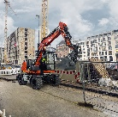
Download images:
KW095 Working in city centre

Follow us on:
 Website: https://www.kubota.com , https://www.kubota-eu.com
 LinkedIn: https://www.linkedin.com/company/kubota/, https://www.linkedin.com/company/kubota-in-europe/
 Facebook: https://www.facebook.com/KubotaEurope/
 Instagram: https://www.instagram.com/kubota_in_europe
 YouTube: https://www.youtube.com/@KUBOTAEurope

