PRESS RELEASE
February 18, 2025

Kubota sets new standards in the 1.5 - 2 Tonne Range with the new U17-5 and U18-5
Kubota unveils the brand new U17-5, the latest in the U17 series of mini diggers, redefining excellence in the 1.5-tonne, zero tail swing range
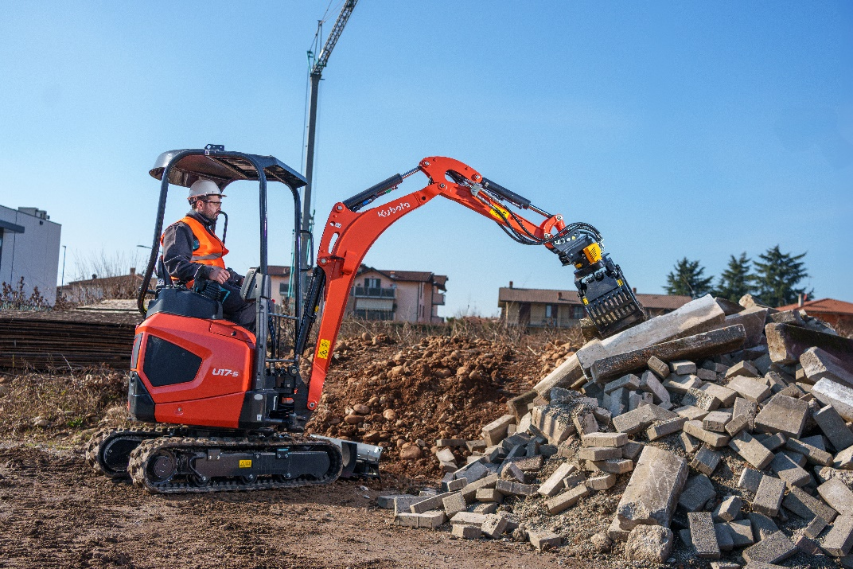

Picture: New U17-5 & U18-5

Building on its reputation as a top performer, the U17-5 introduces a host of upgrades that enhance efficiency, performance, and operator comfort, ensuring this machine remains the benchmark in its category.
When designing a successor to a market-leading machine trusted and beloved by thousands of customers worldwide, preserving its core strengths is just as crucial as introducing enhancements. The U17-5 maintains everything that made its predecessor a favourite while incorporating carefully considered upgrades to elevate its performance and user experience.

Since its debut in 2008, the U17-3 has set the standard for reliability and performance. With valuable feedback from our customers driving its evolution, the U17-5 builds on everything people loved about the previous model and takes it to the next level.
The U17-5 introduces a new 20L fuel tank, which is 5% larger than its predecessor, coupled with the auto-idle feature that contributes to lower fuel consumption. These enhancements not only improve fuel efficiency but also significantly reduce noise levels, making the machine particularly suited for use in urban environments.
With an extendable undercarriage that has been increased to 1300mm, the U17-5 achieves more in both side and front stability. The machine offers better manoeuvrability and increased ground clearance, improving its overall performance and adaptability to challenging terrains.
The hydraulic system of the U17-5 now includes a new independent travel circuit, allowing operators to use the boom, dipper, bucket, and auxiliary functions without compromising tracking performance. This addition guarantees seamless operation and improved efficiency, even in demanding conditions.
Staying true to Kubota's dash 5 philosophy, the U17-5 incorporates additional safety features, enhanced serviceability, and a modernised design. While embracing these extras, the machine retains the hallmark for reliability and ease of operation that the U17 series is renowned for.
Adding to this series is the new U18-5, a long dipper arm model which has seen further developments with a revised rear counterweight design and undercarriage which has added 67kg from the previous model (U17-3a). Despite a slightly longer tail (30mm), it retains its zero-tail swing configuration, offering superior stability and flexibility.
The U17-5 and U18-5 embodies Kubota’s dedication to delivering machines that offer "everything you want and nothing you don’t." By carefully pairing the high-performance engine with hydraulic pumps, valves, and motors, ensuring a seamless balance of power and precision.
Kubota once again reaffirms its commitment to setting industry standards.

About Kubota
Kubota has been a leading manufacturer of agricultural equipment, construction equipment, lawn mowers and Industrial Engines since 1890. With its global Headquarters in Osaka Japan, offices in more than 120 countries, and more than 55,000 employees in North America, Europe and Asia. Although machinery equipment is its main products line, Kubota also produces a wide range of products such as city water purification systems, irrigation systems, piping systems, roof and home construction, and large underground valves.

Our Mission
Our Brand Statement, “For Earth, For Life,” speaks to our commitment to the conservation of the environment while aiding the production of food and water supplies, which are vital to meet the needs of our society, as the world’s population continues to grow. This mission is accomplished every time a Kubota tractor harvests the land to produce food or when our construction equipment excavates to transport water or provide shelter. For more information on Kubota, please visit www.kubota-eu.com or www.kubota.com.

For further information, please contact

Construction PR Manager
Will Pike

will.pike@Kubota.com


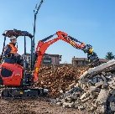
Download images:
U17-5 Working on site with grapple

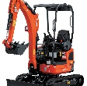

U17-5 Studio image

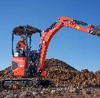
U18-5 Working onsite

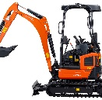
U18-5 Studio image

Follow us on:
 Website: https://www.kubota.com , https://www.kubota-eu.com
 LinkedIn: https://www.linkedin.com/company/kubota/, https://www.linkedin.com/company/kubota-in-europe/
 Facebook: https://www.facebook.com/KubotaEurope/
 Instagram: https://www.instagram.com/kubota_in_europe
 YouTube: https://www.youtube.com/@KUBOTAEurope

