PRESS RELEASE
February 18, 2025

Kubota launches the SVL75-3 compact track loader to the European market

Kubota is excited to unveil the new SVL75-3 compact track loader, a machine engineered to set new standards and versatility for operators across Europe.

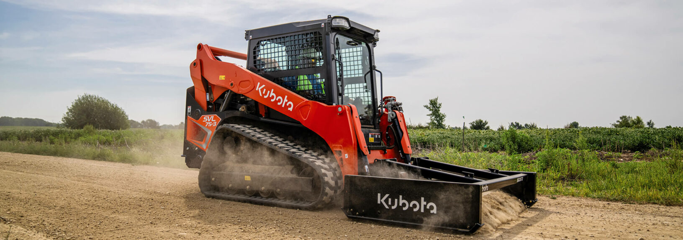

Picture: SVL75-3

Designed from the ground up to meet the demands of modern job sites, the SVL75-3 delivers powerful capability in a compact and durable package.

At the heart of the SVL75-3 is a powerful 74 HP Kubota engine, delivering impressive torque to tackle a wide range of tasks, including digging, grading, material handling, and dumping. This machine is built to thrive in the toughest environments, offering renowned Kubota reliability and performance.

The SVL75-3 features a one-piece, fully sealed, and pressurised cabin, designed to protect operators from dirt, dust, water, and debris while ensuring a clean and comfortable workspace. The spacious cab offers a wide entrance, front sliding window for easy access, and ergonomically designed controls for maximum operator convenience. Six strategically placed vents ensure optimal airflow for heating and cooling, while an elevated A/C filter maintains clean air circulation for maximum comfort.

This state-of-the-art machine is equipped with advanced technology to streamline operations and improve operator efficiency. A 7-inch LCD touch screen provides intuitive controls, keyless start functionality, and an integrated reverse camera, enhancing both convenience and safety. The SVL75-3 also boasts an advanced hydraulic system capable of powering a variety of attachments, available in both standard and high-flow configurations.

The innovative engine layout enhances serviceability and ensures dependable performance, underscoring Kubota’s commitment to delivering machines that operators can rely on. Every detail of the SVL75-3 has been carefully crafted to meet the demands of today’s job sites, from its durability to its operator-focused design.

With the auto-shift function now standard, the machine operates more smoothly by automatically downshifting when approaching a corner and upshifting when back on a straight path, this also benefits applications like dozing.

Additionally, the machine features an advanced multifunction valve that ensures seamless hydraulic operation. This enables the operator to simultaneously control the AUX hydraulics, bucket, and loader arm without stalling.

With impressive specifications, the SVL75-3 is ready to take on any challenge:

- Rated operating capacity: 1,129 kg at 35% tipping load; (1,613 kg) at 50% tipping load.
- Bucket breakout force: 2,710kg
- Operating weight: 4,271 kg for closed cab.
- Travel speed: Low gear at 9.0 km/h; high gear at 13.7 km/h.

The SVL75-3 represents a new era in Kubota’s ever-growing portfolio, and one that will open many more opportunities across Europe, all while staying true to Kubota’s commitment to operator-focused design.

About Kubota
Kubota has been a leading manufacturer of agricultural equipment, construction equipment, lawn mowers and Industrial Engines since 1890. With its global Headquarters in Osaka Japan, offices in more than 120 countries, and more than 55,000 employees in North America, Europe and Asia. Although machinery equipment is its main products line, Kubota also produces a wide range of products such as city water purification systems, irrigation systems, piping systems, roof and home construction, and large underground valves.

Our Mission
Our Brand Statement, “For Earth, For Life,” speaks to our commitment to the conservation of the environment while aiding the production of food and water supplies, which are vital to meet the needs of our society, as the world’s population continues to grow. This mission is accomplished every time a Kubota tractor harvests the land to produce food or when our construction equipment excavates to transport water or provide shelter. For more information on Kubota, please visit www.kubota-eu.com or www.kubota.com.

For further information, please contact

Construction PR Manager
Will Pike

will.pike@Kubota.com


Follow us on:
 Website: https://www.kubota.com , https://www.kubota-eu.com
 LinkedIn: https://www.linkedin.com/company/kubota/, https://www.linkedin.com/company/kubota-in-europe/
 Facebook: https://www.facebook.com/KubotaEurope/
 Instagram: https://www.instagram.com/kubota_in_europe
 YouTube: https://www.youtube.com/@KUBOTAEurope

