PRESS RELEASE
February 19, 2025

Kubota launches electric retrofit solution for KX019-4e & U27-4e Excavators

Kubota, a renowned leader in the construction industry, is now making bold strides forward with a groundbreaking innovation in electric excavator design.
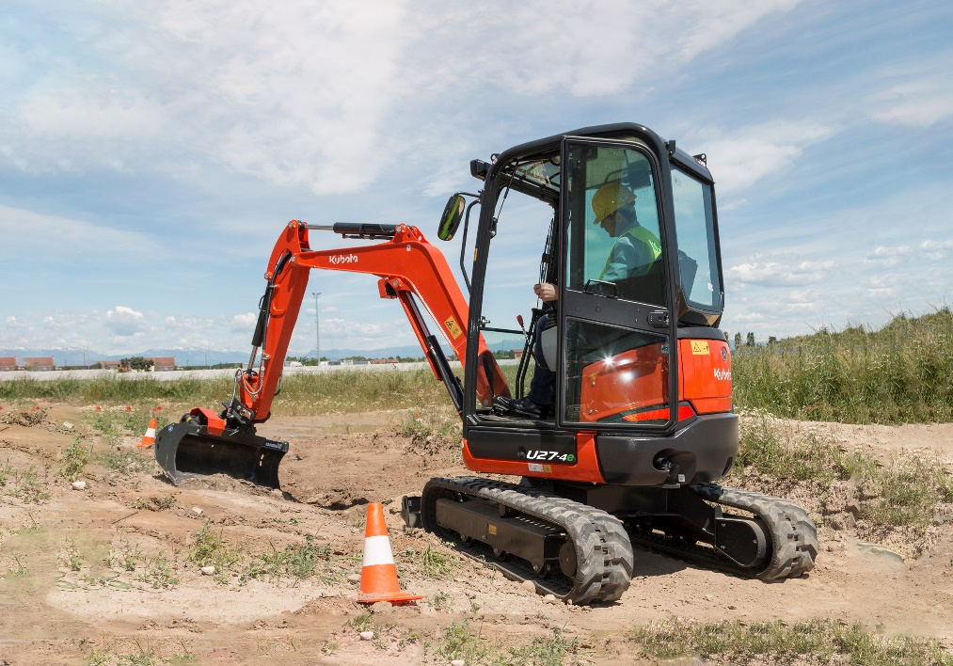

Picture: Electric Retrofit U27-4E

Kubota first introduced its prototype 2.5 tonne electric excavator at Intermat in 2012, marking the beginning of its journey into electrification within the construction industry. Now, the company is taking another significant step forward by unveiling an electric retrofit option for the KX019 (1.8-tonne) and U27-4 (2.5-tonne) diggers. This innovative concept aims to make the transition to electric equipment more accessible and practical for the construction industry.

With global demand for sustainable alternatives on the rise, Kubota is addressing a key industry need: reusability and longevity of machinery. The new solution enables customers to replace the standard diesel engine of their excavator with a modular battery pack. Alternatively, machines can be fitted with the battery pack from new and later swapped out for a diesel engine or vice versa.

Cost has always been a barrier to adopting electric machinery. But with this retrofit solution, customers gain flexibility. They can enjoy the low running costs of electric and still have the option to switch to diesel if necessary. It’s about providing choice and easing the transition to a greener future.

Kubota’s solution also notably reduces maintenance costs and operational overheads. With no engine and associated components, servicing time and expenses are considerably reduced, saving customers both time and money. Additionally, with electricity costing far less than fossil fuels, it offers a highly economical advantage.

But this isn’t all, the retrofit solution delivers low noise levels, making it ideal for urban environments and indoor applications. Noise levels at the operator station is significantly lower compared to the diesel equivalent, enabling better communication and safety with co-workers. Quiet operation also allows for longer working days, maximising time on-site and accelerating project timelines.

Kubota’s solution addresses the unique needs of construction operators, recognising that many machines only operate for a few hours a day, often less than two hours. The battery pack’s runtime aligns with this usage, and with the ability to top up charges throughout the day, working hours can be easily extended.

While electric models are yet to dominate the market, Kubota’s approach is focused and practical, aimed at providing an easier path to adopting electric technology without abandoning the flexibility of existing diesel setups. By offering a solution that bridges the gap between traditional and electric machinery, Kubota is making significant strides towards a more sustainable industry.

The electric retrofit is expected to roll out throughout 2025.

About Kubota
Kubota has been a leading manufacturer of agricultural equipment, construction equipment, lawn mowers and Industrial Engines since 1890. With its global Headquarters in Osaka Japan, offices in more than 120 countries, and more than 55,000 employees in North America, Europe and Asia, Kubota had a turnover of $21.4 billion in 2023. Although machinery equipment is its main products line, Kubota also produces a wide range of products such as city water purification systems, irrigation systems, piping systems, roof and home construction, and large underground valves.

Our Mission
Our Brand Statement, “For Earth, For Life,” speaks to our commitment to the conservation of the environment while aiding the production of food and water supplies, which are vital to meet the needs of our society, as the world’s population continues to grow. This mission is accomplished every time a Kubota tractor harvests the land to produce food or when our construction equipment excavates to transport water or provide shelter. For more information on Kubota, please visit www.kubota-eu.com or www.kubota.com.

For further information, please contact

Construction PR Manager
Will Pike

will.pike@Kubota.com


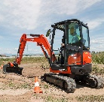
Download images:
U27-4 Electric Retrofit Working in field
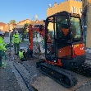

U27-4 Electric Retrofit Working in town centre

Follow us on:
 Website: https://www.kubota.com , https://www.kubota-eu.com
 LinkedIn: https://www.linkedin.com/company/kubota/, https://www.linkedin.com/company/kubota-in-europe/
 Facebook: https://www.facebook.com/KubotaEurope/
Instagram: https://www.instagram.com/kubota_in_europe
 YouTube: https://www.youtube.com/@KUBOTAEurope

