PRESS RELEASE
February 20, 2025

Kubota produces its millionth excavator

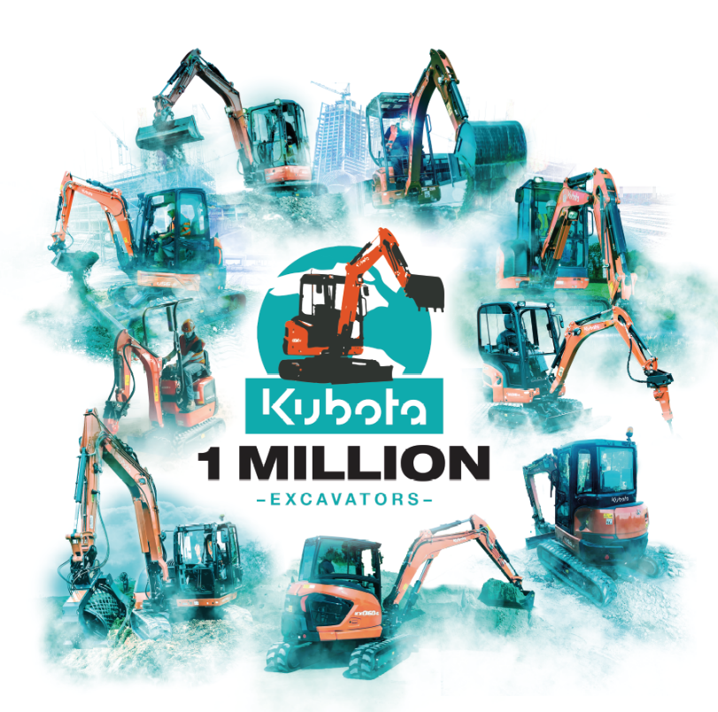
Kubota is globally renowned for its quality and reliability, offering products for a wide range of applications, including construction, agriculture, groundcare, and more. Building on this rich heritage and history, Kubota proudly celebrates the production of its 1,000,000th excavator.

Picture: 1 Million excavators produced

From humble beginnings to a world-class leader, Kubota’s journey in excavator production began in 1974 with the KH1, the company’s first mini excavator. This groundbreaking machine set a new standard for compact construction equipment and by 1979, Kubota expanded its range with the KH4 and KH7 models, introducing enhanced versatility to meet diverse customer needs, this year was also the introduction of Kubota excavators in Europe.
The game-changing KX series debuted in 1988, offering refinements in hydraulic performance, durability, and operator comfort. Kubota’s commitment to innovation continued in 1999 with the launch of the U Series, which pioneered zero-tail swing technology for superior manoeuvrability in tight spaces.
In 2002, Kubota celebrated the production of its 100,000th excavator, a testament to its rapid growth and global impact. Four years later, the company introduced the KX080-3, its largest excavator to date, designed for heavy-duty applications while maintaining the quality and reliability Kubota is known for.
Kubota continues to lead the way in Europe as the number one brand for excavators up to 8 tonnes. Celebrating the milestone of producing 1,000,000 excavators, this remarkable achievement highlights Kubota’s commitment to quality and innovation, as well as the loyalty of its customers worldwide.
One million excavators is more than a number; it’s an indication of trust, innovation, and the hard work of everyone at Kubota. Kubota is proud to have supported countless industries and communities globally, and this milestone will continue to shape the future of machinery with customers at the forefront of future developments.
As Kubota celebrates this achievement, it reaffirms its commitment to pushing the boundaries of technology and sustainability. Looking ahead, Kubota aims to maintain its position as a market leader, driving progress in construction, agriculture, and groundcare through customer-centric solutions.

About Kubota
Kubota has been a leading manufacturer of agricultural equipment, construction equipment, lawn mowers and Industrial Engines since 1890. With its global Headquarters in Osaka Japan, offices in more than 120 countries, and more than 55,000 employees in North America, Europe and Asia. Although machinery equipment is its main products line, Kubota also produces a wide range of products such as city water purification systems, irrigation systems, piping systems, roof and home construction, and large underground valves.

Our Mission
Our Brand Statement, “For Earth, For Life,” speaks to our commitment to the conservation of the environment while aiding the production of food and water supplies, which are vital to meet the needs of our society, as the world’s population continues to grow. This mission is accomplished every time a Kubota tractor harvests the land to produce food or when our construction equipment excavates to transport water or provide shelter. For more information on Kubota, please visit www.kubota-eu.com or www.kubota.com.

For further information, please contact

Construction PR Manager
Will Pike

will.pike@Kubota.com


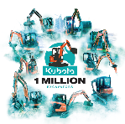
Download images:
1 Million Excavators Produced

Follow us on:
 Website: https://www.kubota.com , https://www.kubota-eu.com
 LinkedIn: https://www.linkedin.com/company/kubota/, https://www.linkedin.com/company/kubota-in-europe/
 Facebook: https://www.facebook.com/KubotaEurope/
 Instagram: https://www.instagram.com/kubota_in_europe
 YouTube: https://www.youtube.com/@KUBOTAEurope

